**WEEK - 3**

Use Git to perform the following tasks

d) Manage remote repositories(push,pull etc.)

e) Branching and Merging(branch, merge,checkout etc.)

f) Recovery management(restore,reset, revert etc.)

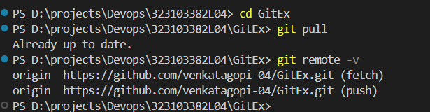

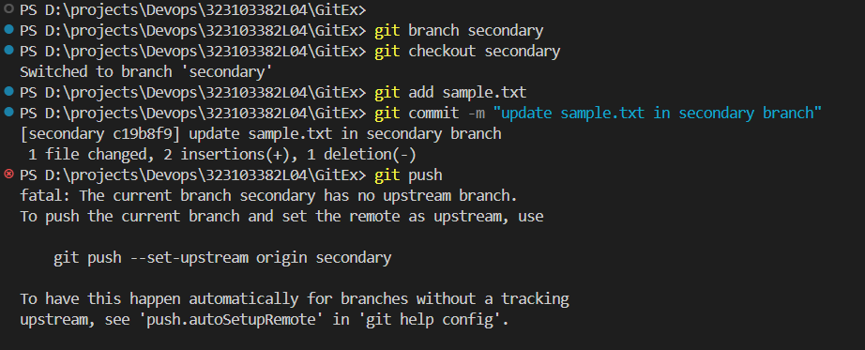

**Created new Branch “Secondary”**

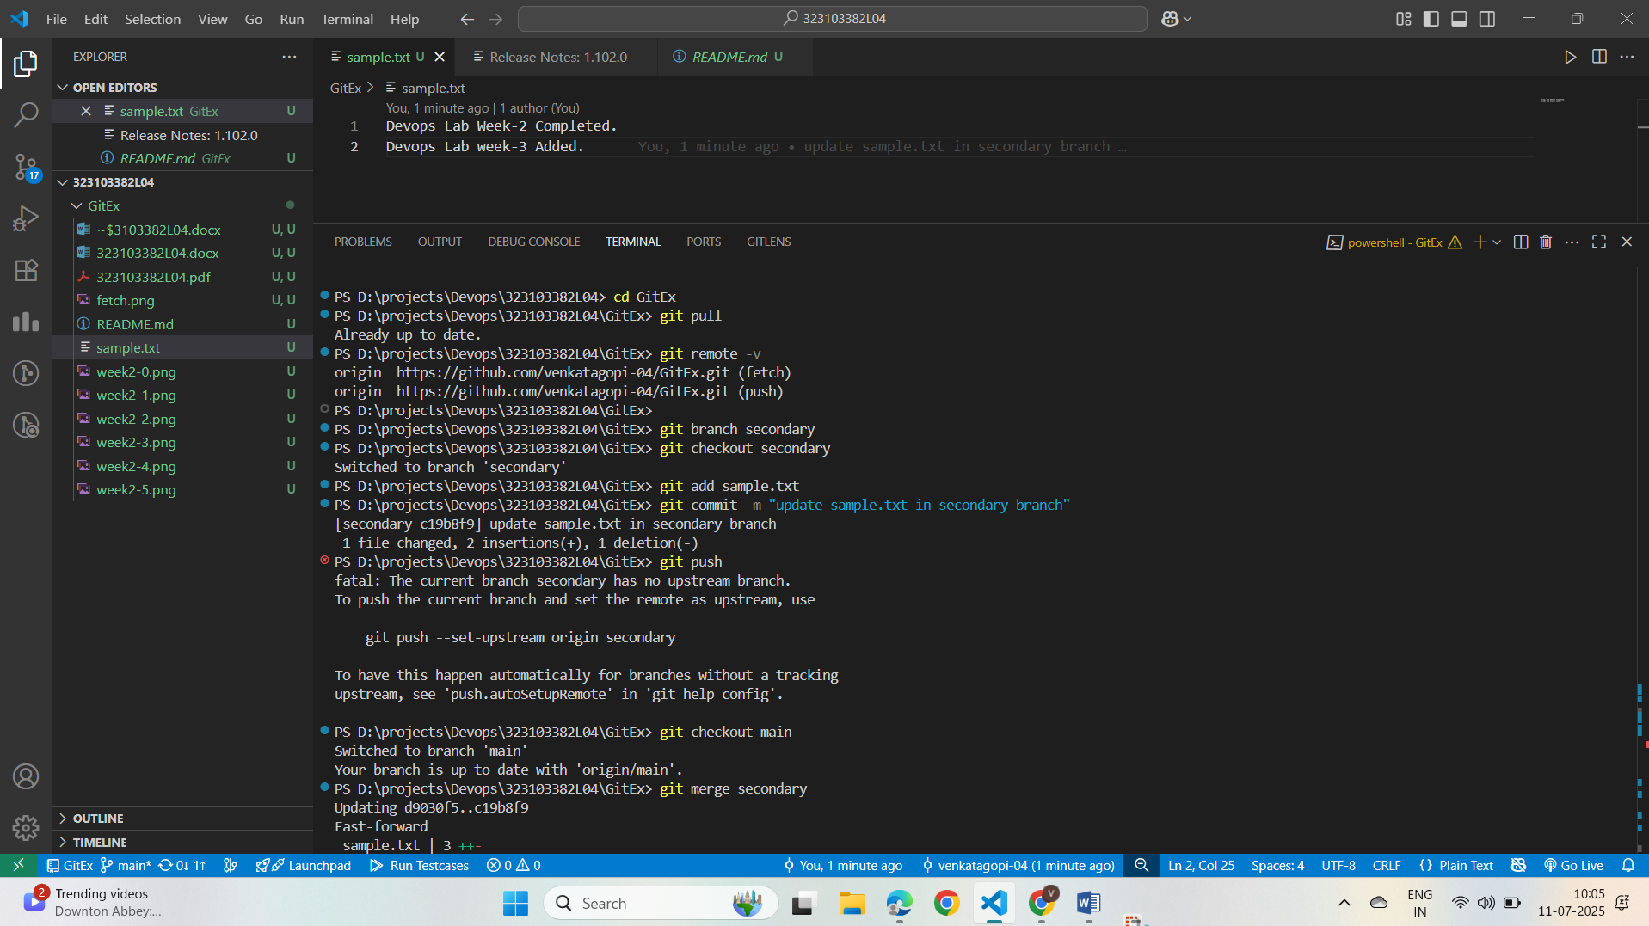**Update an existing file “sample.txt” and added into the secondary branch.**

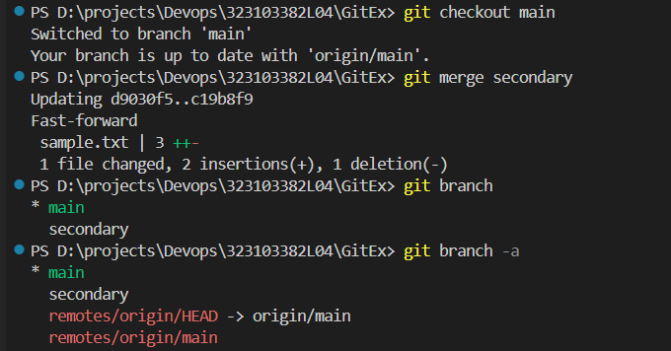

**Merged Secondary branch and Main Branch**

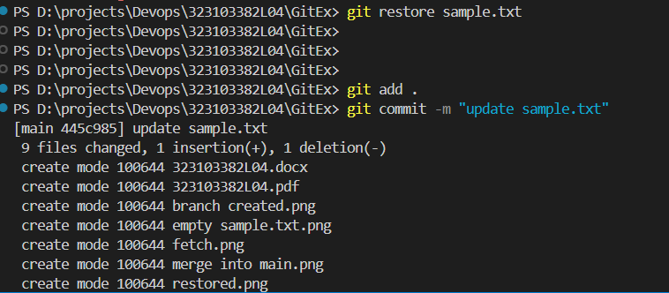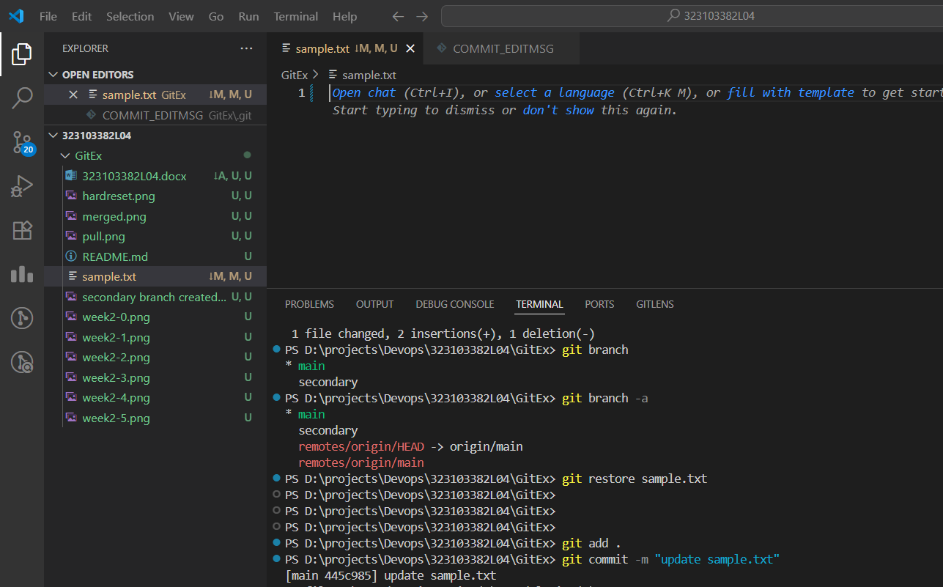**Deleted content of sample .txt**

**Restored the contents of sample.txt using**

**“git restore sample.txt”**

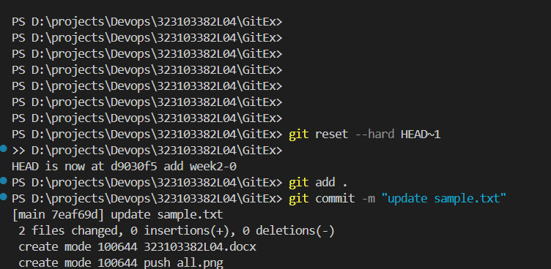**Performed the Hard Resetting of Staging area.**

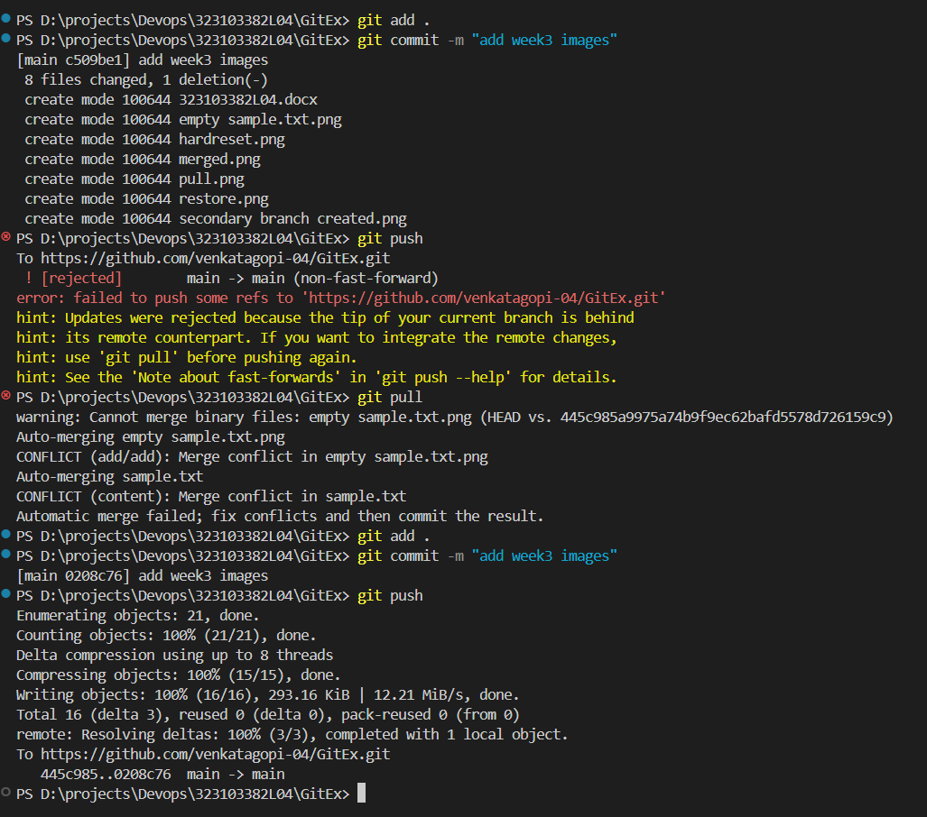

**Solved the Merge Conflict by Pull the remote repo back again and the performed Push operation.**